W2 PRACTICE
MOBILE UI HEURISTICS

In this research work, you will work on a specific mobile interaction scenario in terms of UI heuristics

- This work needs to be performed and presented in pairs.

Learning objectives
- Develop a deep understanding of Mobile UI heuristics
- Take the right decisions in terms of UI components - given a real-world problem

How to submit?
- Attach your report to the MS Team assignment and turn it in
- Present your research outcomes to the class

 Website to should start your researches from!

Material Design Patterns
https://m1.material.io/patterns/navigation.html

User Interface Design pattern
https://ui-patterns.com/patterns

Design-Pattern Guidelines
https://www.nngroup.com/articles/design-pattern-guidelines

A - READ UI HEURISTICS

The first step of this activity is to take time to read UI heuristics resources:

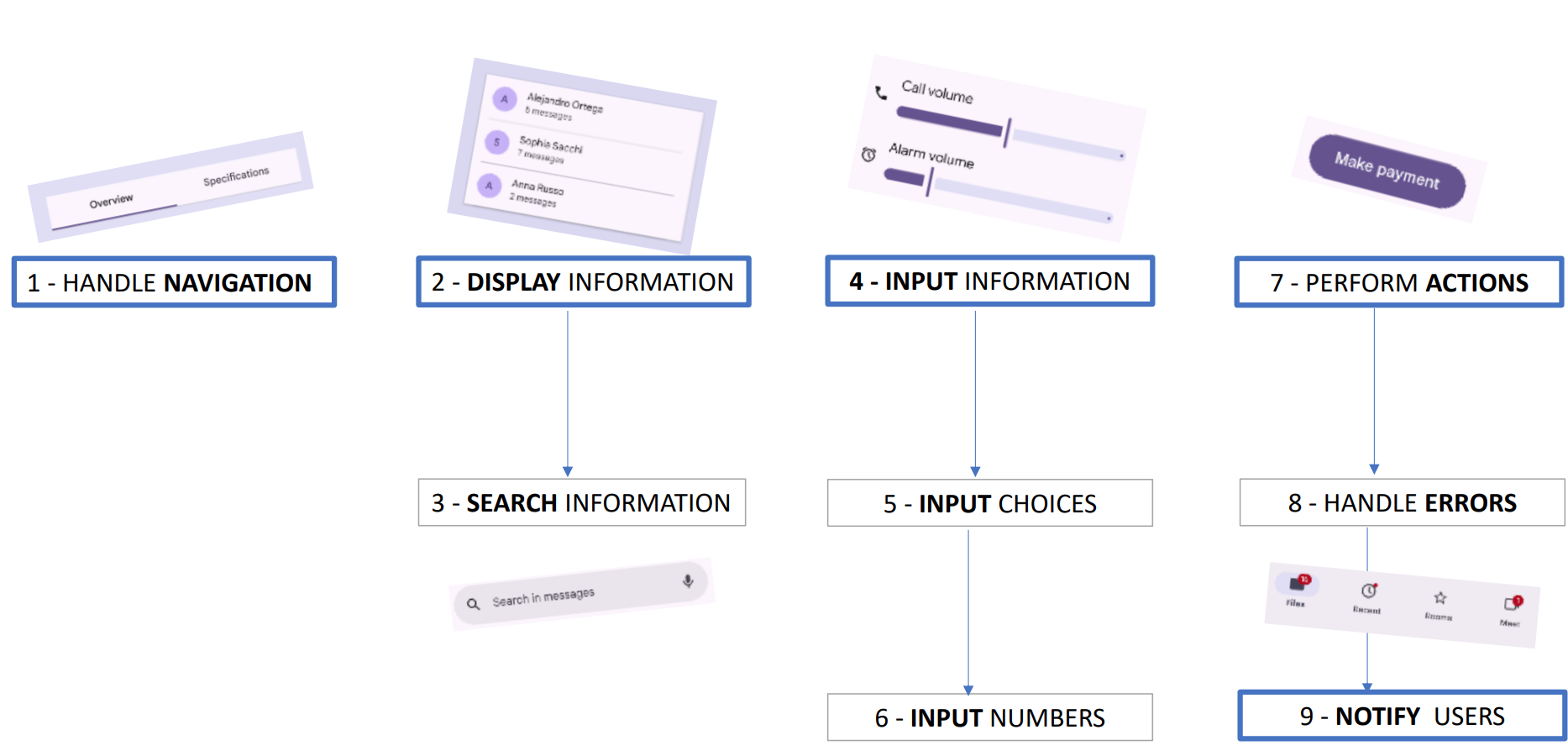

1 - HANDLE NAVIGATION

COMPONENTS
https://m3.material.io/components/bottom-app-bar
https://m3.material.io/components/navigation-bar
https://m3.material.io/components/navigation-drawer
https://m3.material.io/components/navigation-rail
https://m3.material.io/components/tabs/overview
https://m3.material.io/components/dialogs/overview
https://m3.material.io/components/top-app-bar/overview

HEURISTICS
https://m1.material.io/patterns/navigation.html
https://m1.material.io/patterns/navigation.html#navigation-combined-patterns
https://www.smashingmagazine.com/2017/05/basic-patterns-mobile-navigation
https://ui-patterns.com/patterns/modal-windows
https://www.storyly.io/post/basic-patterns-for-mobile-navigation-and-the-best-practices

2 - DISPLAY INFORMATION

COMPONENTS
https://m1.material.io/patterns/empty-states.html
https://www.nngroup.com/videos/accordions-on-mobile/?lm=mobile-input-fields&pt=youtubevideo
https://ui-patterns.com/patterns/cards
https://www.nngroup.com/articles/infinite-scrolling-tips/
https://ui-patterns.com/patterns/ContinuousScrolling
https://ui-patterns.com/patterns/Pagination
https://ui-patterns.com/patterns/Carousel
https://www.nngroup.com/videos/avoid-accordions/

HEURISTICS
https://m3.material.io/components/lists/overview
https://m3.material.io/components/cards/overview
https://m3.material.io/components/bottom-sheets/overview
https://m3.material.io/components/carousel/overview

4 - INPUT INFORMATION

COMPONENTS
https://m1.material.io/components/steppers.html
https://m3.material.io/components/bottom-sheets/overview
https://m3.material.io/components/carousel/overview

HEURISTICS
https://www.nngroup.com/articles/wizards/
https://blog.mobiscroll.com/building-great-mobile-forms/
https://www.nngroup.com/videos/mobile-input-fields/
https://ui-patterns.com/patterns/expandable-input
https://ui-patterns.com/patterns/WYSIWYG

5 - INPUT CHOICES

COMPONENTS
https://m3.material.io/components/checkbox/overview
https://m3.material.io/components/switch/overview
https://m3.material.io/components/radio-button/overview
https://m3.material.io/components/chips/overview

HEURISTICS
https://www.nngroup.com/articles/toggle-switch-guidelines/
https://www.nngroup.com/articles/checkboxes-vs-radio-buttons/

6 - INPUT NUMBERS

COMPONENTS
https://m3.material.io/components/text-fields/overview
https://m3.material.io/components/sliders/overview
https://m3.material.io/components/chips/overview

HEURISTICS
https://www.nngroup.com/articles/input-steppers/
https://www.nngroup.com/articles/sliders-knobs/
https://www.nngroup.com/articles/mobile-input-checklist/
https://www.nngroup.com/videos/mobile-input-fields/

7 - PERFORM ACTIONS

COMPONENTS
https://m3.material.io/components/buttons/overview
https://m3.material.io/components/floating-action-button/overview
https://m3.material.io/components/icon-buttons/overview
https://m3.material.io/components/segmented-buttons/overview

HEURISTICS
https://uxdworld.com/design-accessible-buttons/

8 – HANDLE ERRORS

COMPONENTS
https://m3.material.io/components/buttons/overview
https://m3.material.io/components/floating-action-button/overview
https://m3.material.io/components/icon-buttons/overview
https://m3.material.io/components/segmented-buttons/overview

HEURISTICS
https://m1.material.io/patterns/errors.html
https://www.nngroup.com/articles/hostile-error-messages/
https://www.nngroup.com/videos/mobile-error-handling-alerts/
https://www.nngroup.com/articles/confirmation-dialog/

9 - NOTIFY USERS

COMPONENTS
https://m1.material.io/patterns/notifications.html
https://m3.material.io/components/badges/overview
https://m3.material.io/components/dialogs/overview
https://m3.material.io/components/snackbar/overview

HEURISTICS
https://m1.material.io/patterns/notifications.html
https://uxplanet.org/how-to-craft-mobile-notifications-that-users-actually-want-7b585e0e1fa1
https://www.toptal.com/designers/ux/notification-design

UI HEURISTICS – WRAP UP
USE CASE | RELATED UI COMPONENTS | QUESTIONS TO CONSIDER
1- Handle Navigation | Navigation Bar  App Bar  Bottom bar  Drawer / Navigation Rail  Tabs  Contextual Menu  Dialog | How important is the task?  How frequent is the task?  Does the task should be put with other tasks?  Should we interrupt current user’s task?  Should we catch the user’s full attention?  How deep in the navigation tree?
2-Display Information | Cards  Tables and Lists  Bottom Sheet  Accordion  Carousel | How much data to display?  How many items per screen?  Consider the empty State pattern  Consider infinite scroll or pagination
3-Search Information | Free text to search  Components to filter  Table to sort  Grouping items | Tolerance to typos, synonyms?  Multiple filters?  Can user remove the filter settings?
4-Create Information | Forms  Wizards/ Steppers  Bottom Sheet  Accordion | Does the data to enter must follow a process?  Can we identify optional information?  Should default value be provided
5-Input choices | Checkbox  Switch  Radio Button  Dropdown  Chips | How many choices are available?  How many selections can the user make?  Is there a default option?  Are the choices depending on each other?
6- Input numbers | TextField  Slider  Dropdown  Chips | How many numbers are available?  Can many numbers be selected?  Is there a default option?
7- Perform Actions | Call to Action Button  Secondary Button  Floating Button | What is most important action? Secondary actions?  Is the action recoverable?  Is the action always available?
8-Handle Errors | Error Labels  Snack bar  Dialogs | When validation should error?  (On edition, on submit, after submitted.)  What is the level of error?
9- Inform Users | Badges  Dialogs  Push Notifications (external)  In-App Banners  Snack bar | Does the information require to interrupt the user?  Does the information need to stay?

B - APPLY UI HEURISTICS

In this practice you will have to work on 2 scenarios (see below)

For each scenario you need to:

- IDENTITY UI COMPONENTS

Identify UI components you want to choose, which criteria you consider and the heuristics that justify your choice (see the heuristics on PART-A).

UI COMPONENTS | CRITERIA | HEURISTIC
Checkbox | Many agreements can be selected | Use checkboxes (instead of switches or radio buttons) if multiple options can be selected from a list

- DESIGN THE WIREFLOW

Provide:
- Screen-to-screen wireflow
- Navigation transitions
- Error states
- Alternative paths
- Back navigation behavior

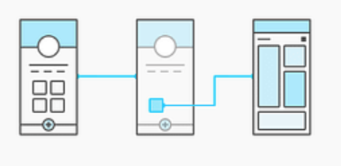

C – SCENARIO PRESENTATION

International Event Registration & Access Pass

As a User, register for a multi-day international event (conference / festival / competition).

Identity
Full name
Date of birth | (18 years or greater)
Nationality
ID type (Passport / National ID) | Some countries have different ID formats
Attendance Details
Attendance type | Full / multiple day / online
Days attending | In case of multiple days - event can have multiple days
Sessions | 80+ choices - only the ones that applies
Add-Ons
Lunch attended | Shall be compliant with the attendance
Insurance | Insurance required for foreign attendees
Parking
Payment Information
Payment method
Billing country
Tax number | optional / required depending on country
Promo code
Review & confirm
Summary
Legal agreements | Many agreements shall be approved
Payment confirmation

YOUR WORK HERE

